UFO Sighting Distribution in U.S.

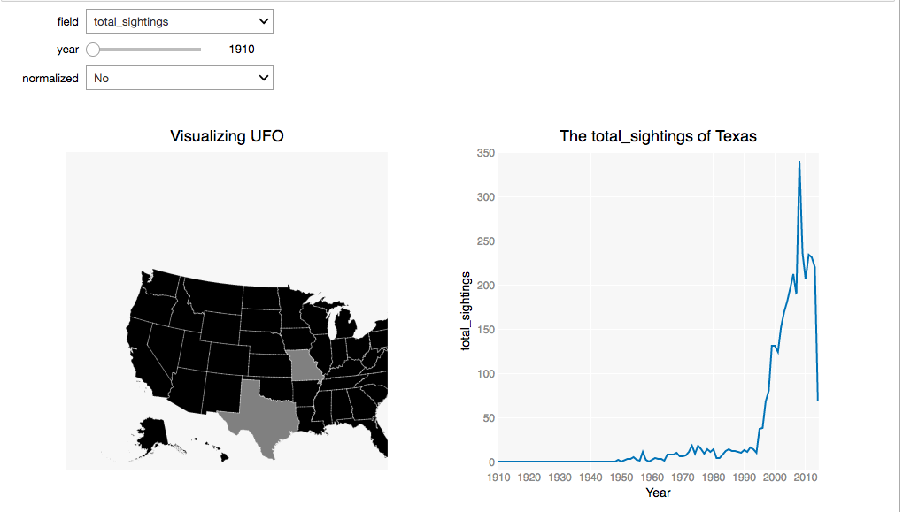

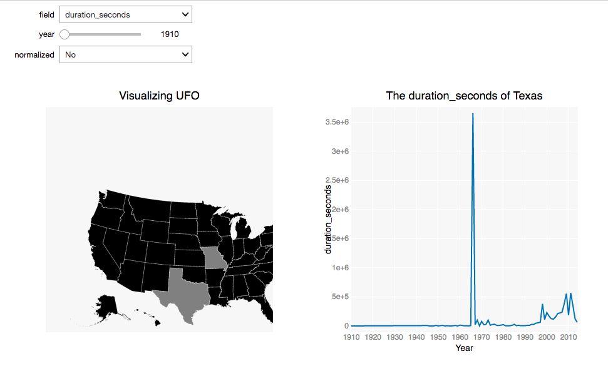

The first plot is the distribution of UFO total sightings in U.S. We use different colors to represent different numbers. Black presents 0 while grey represents 1. The first time of reporting UFO was in 1910. There were only two reports in that year, one in Texas and one in Missouri. When clicking on a state in the map, we can see the trend of total sightings of that state from 1910 to 2014. The plot on the right side shows the trend of the trend of total sightings of Texas. As we can see from the trend line, the total sightings have increased enormously from 1995. The number reached the maximum in 2008 and decreased largely in 2009 and 2014. The second plot is the distribution of UFO duration seconds in U.S. Like the plot of total sightings, we can get the trend of duration seconds of a particular state when clicking on the state. The total duration seconds shown in the plot are the sum of duration seconds of each sighting. The maximum of duration seconds appeared in 1966 while duration seconds in other years were at similar levels. Corresponding to the increase of total sightings from 2005, the duration seconds also increased. However, the maximum of total sightings was in 2008. We can guess that average duration of UFO sighting in 1966 was longer than that in other years. We can explore more information based on the visualization.

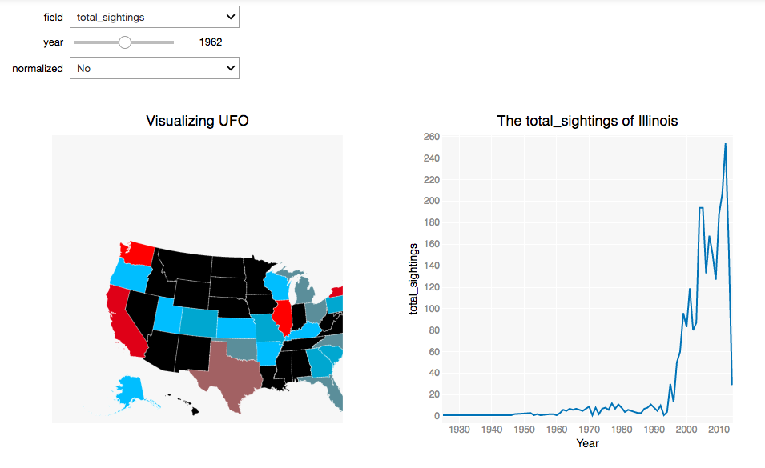

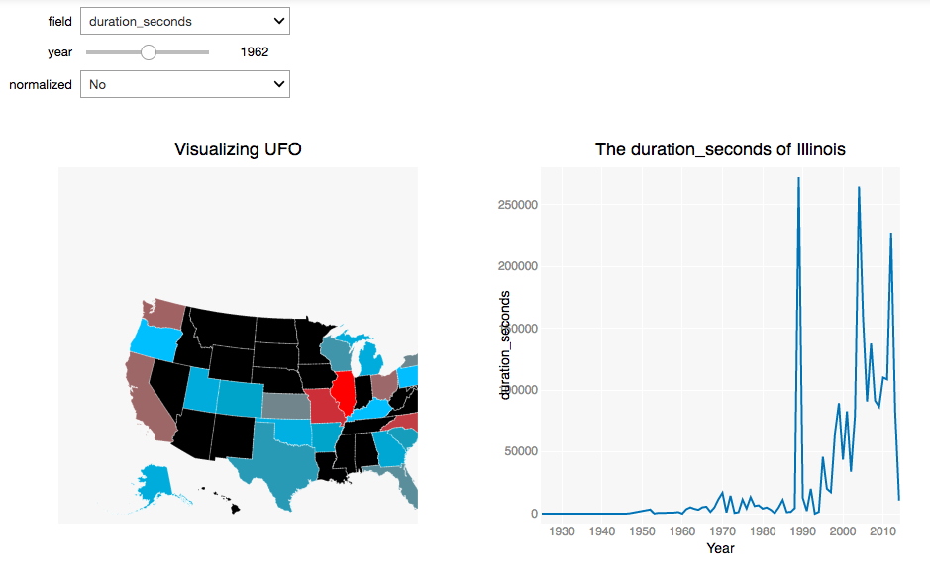

The plots above are the distributions of UFO total sighting and duration seconds in 1962. We select that year because it’s around the midpoint and there were not too many missing values in that year. Since the numbers are very different in 1962, we can get more information from different colors. Red represents relative large numbers, blue presents relative small numbers, and grey represents the middle. We are interested in the trends of the state where we live in. So we click on Illinois. The total sightings of Illinois increased enormously in 1997, 2004, and 2010, and decreased largely in 2014. The numbers of total sightings in Texas and Illinois both decreased a lot in 2014, which might be due to incomplete statistics. And then we check the trends of other states besides Illinois and Texas, the total sightings also decreased sharply in 2014. The UFO duration seconds of Illinois changed dramatically. We can see three peaks in 1989, 2004, and 2012. The plots of duration seconds don’t give us much useful information.